LESSON PLAN

STEALING HOME:

How Race Relations, Politics, and Baseball Transformed Chavez Ravine

Creator: T. DeVere Wolsey, Elsinore Middle School / Grade 8
Created date: 2005
Grade level recommendation: 8 (advanced 8th graders, high school government and history classes)
Time Required:
- Lesson plan 1: 50 minutes
- Lesson plan 2: 100 minutes

Unit Overview

Over the first six decades of the 20th century, federal, state, and city policies changed the lives of the predominantly Mexican-American residents of the peaceful and unified Chavez Ravine communities of Los Angeles. In this unit students learn how new housing laws, racial tensions, fears of communism, and economic realities combined to drive long-time residents out of the area, which became the home of the Los Angeles Dodgers in 1962.

Historical Background

Be it ever so humble, there’s no place like home. — J. Howard Payne

Baseball fans know Chavez Ravine as the home of Dodger Stadium, but that hasn’t always been so. During the first half of the 20th century, these three Los Angeles communities were home to many Mexican-American families. The region still inspires a sense of home for residents who lived there more than 50 years ago. Many students will be familiar with proverbs and homilies such as “Home is where the heart is,” “Home, sweet home,” and “Home is where you hang your hat.” As they use newspaper photographs and the personal papers of a Los Angeles city council member to understand how federal, state, and city policies changed the lives of the people living in Chavez Ravine, they will also have the opportunity to reflect on why the word home and the concepts it represents spark such strong emotions.

In the first four decades of the 20th century, the Chavez Ravine communities were quiet, almost rural, neighborhoods surrounded by the city of Los Angeles. The area was somewhat neglected by the city, with unpaved roads and no access to city sewers, but the predominantly Mexican-American residents had what photographer Don Normark (1999) called a sense of unity. He wrote of his perception that “the people of Chavez Ravine lived lives that were a bit more open than those in more conventional American neighborhoods” (p. 12).

Congress passed the National Housing Act of 1949 to improve the lives and standard of living for a broad range of Americans. The city of Los Angeles approved 11 housing projects, among them the Chavez Ravine site. Residents were told they would have first choice of units in the new housing project and receive assistance in finding a place to live while the housing was constructed. Neither of these promises was kept. Eventually, many residents agreed to sell their property to the city housing authority. Some of these residents found that the city offered less than the property was worth or less than they would need to purchase a new house in another part of the city.

At least two major factors were played out as events unfolded: racial tension, and the anti-Communist fervor of the 1950s.

Racial tension is a theme that cannot be ignored by anyone studying the events leading to construction of Dodger Stadium. The memory of the Zoot Suit Riots and the Sleepy Lagoon murder trials http://www.pbs.org/wgbh/amex/zoot/ still fueled the collective prejudices of many Los Angeles residents against Mexican-Americans living in west Los Angeles. The decision to “improve” largely Mexican-American Chavez Ravine through a federal housing project was a reflection of that prejudice.

At the same time, the powerful force of anti-communism was sweeping the country. The Cold War had divided the nations of the world into competing ideological camps, with far-reaching political ramifications. In the United Sates, Senator Joseph McCarthy and the House Committee on Un-American Activities led a campaign to root out perceived Communists and “subversives” from American government and society. Southern California, with its booming population and high-profile Hollywood entertainment industry, became an especially prominent battleground.

In this contentious political landscape, it was not too much of a stretch for many politicians and their constituents to associate publicly subsidized housing with communism. As recently as 1996, Senator Robert Dole still equated public housing as the nation’s “last bastions of socialism” (Gugliotta, 1996). In 1951, unable to escape the whirlpool of the anti-Communist fervor, the Chavez Ravine project at Elysian Park Heights was cancelled after substantial legal maneuvers and a vote of the citizens of Los Angeles. The U.S. Congress paid $4 million dollars to help the city out of its contract to build housing, with the promise that the city would use the property for a public purpose.

On the other side of the country a private businessman, Walter O’Malley, decided to relocate his business — the Brooklyn Dodgers — to Los Angeles. The city, without a housing project to construct, decided to sell the property to O’Malley — despite the fact that they had promised to use the site for a “public purpose.

In the meantime, 20 families had refused to leave their homes in Chavez Ravine. But as the stadium project moved forward, these remaining residents were forcibly evicted from their homes and the bulldozers moved in. By 1962, the Dodgers had a new stadium in Los Angeles.

Conceptual Links to Prior Understanding and Knowledge

- Students should be familiar with the chronology of the dispute.
- Basic geographical knowledge about the Los Angeles area would be beneficial and could be provided by posting a road map of the city on a bulletin board for reference.
- Middle and high school students will need some understanding of the federal role in funding various projects that Congress and the Executive branch deem important. For example, prior to 1949, the Federal government had taken a very limited role in the development of the nation’s cities, leaving this largely to the cities themselves and the states where those cities were located.
- Edward Roybal was a Mexican-American city councilman elected in 1949. http://bioguide.congress.gov/scripts/biodisplay.pl?index=R000485
- Fletcher Bowron was mayor of Los Angeles prior to June 1953. Norris Poulson was mayor until June 1961 (California Biographical Dictionary, 4th ed. 1998).
CALIFORNIA CONTENT STANDARDS

History-Social Science

Grades 6–8:
Chronological and Spatial Thinking: 1. Students explain how major events are related to one another in time.
Research, Evidence, and Point of View: 1. Students frame questions that can be answered by historical study and research. 4. Students assess the credibility of primary and secondary sources and draw sound conclusions from them. 5. Students detect the different historical points of view on historical events and determine the context in which the historical statements were made (the questions asked, sources used, author's perspectives).
Historical Interpretation: 1. Students explain the central issues and problems from the past, placing people and events in a matrix of time and place.
Grades 9–12:
Chronological and Spatial Thinking: 3. Students use a variety of maps and documents to interpret human movement, including major patterns of domestic and international migration, changing environmental preferences and settlement patterns, the frictions that develop between population groups, and the diffusion of ideas, technological innovations, and goods.
Historical Interpretation: 1. Students show the connections, causal and otherwise, between particular historical events and larger social, economic, and political trends and developments. 2. Students recognize the complexity of historical causes and effects, including the limitations on determining cause and effect. 3. Students interpret past events and issues within the context in which an event unfolded rather than solely in terms of present-day norms and values. 4. Students understand the meaning, implication, and impact of historical events and recognize that events could have taken other directions.

NATIONAL STANDARDS

Civics and Government

Grades 5–8:
Standard 1 A (2): Necessity and purposes of government. Students should be able to evaluate, take, and defend positions on why government is necessary and the purposes government should serve. Evaluate competing ideas about the purposes government should serve, e.g., protecting individual rights and promoting the common good.
Grades 9–12:
Standard 2 b (4): Diversity in American society. Students should be able to evaluate, take and defend positions on issues regarding diversity in American life. To achieve this standard, students should be able to explain the impact on American politics, both historically and at present, of the racial, religious, socioeconomic, regional, ethnic, and linguistic diversity of American society.

EXPECTATIONS FOR EXCELLENCE http://www.ncss.org/standards

Social Studies
Ten Thematic Strands in Social Studies: Standard 6: Power, Authority, and Governance. Social studies programs should include experiences that provide for the study of how people create and change structures of power, authority, and governance.

LESSON PLAN 1

Time required: 50 minutes

Materials

- Display copies of the Set 1 photographs (See Images 1-5 in the Primary Sources section of this lesson plan.)
- Copies of the Chronology (see Appendix) for each student or each student group.
- Map of Los Angeles from the Internet or travel club.
- Transparencies or other presentation method for quotes displayed during the lesson.

Objectives

- Understand that people put particular significance on the places they regard as their homes.
- Be able to connect the advent of the pioneering National Housing Act of 1949 with the unintended consequences for citizens the law was supposed to help.
- Use primary source documents to reconstruct an understanding from different perspectives on the events affecting the Chavez Ravine communities.

Assessment

- Written paragraph
- Discussion
- Opinion paper
- Class presentations
- Timeline

Cross-Curricular Connections

- Students’ written work (opinion paper and synthesis paragraph) will require particular composition skills and models of similar work that can be correlated with work in English Language-Arts.
- Well-constructed timelines require precision measurement and demonstrate mathematical understanding of the symbolic representation of time passage.

Introduction

As a whole class or in small groups, have students brainstorm all the possible meanings and synonyms for the word home, and for related concepts, such as homesick. Encourage students to think not only of meanings such as “a residence,” but also to think more broadly, such as “an individual’s city or country.” This can be completed as a simple list or in a cluster format. After students finish, they may use a dictionary to discover other definitions they did not come up with on their own. Ask students to specify what qualities make a place a home. Time: 15 minutes.

Direct Teaching

Display the Set 1 photographs from the Daily News and Los Angeles Times in 1950 and 1951. Display the “Lil Town” photograph last. In a whole-class discussion, ask students to review the primary source documents and review the following (Potter 2003):

- What type of documents are these?
- When were they created?
- What could the purpose of the photographs have been?
- What questions do the photographs raise?

Students should see that these are pictures of people’s homes. Tell students that the Chavez Ravine community was made up of three neighborhoods: Palo Verde, La Loma, and Bishop (Tawa 1999; Normark 1999, p. 12). Ask students to speculate how the person who put up the “Lil Town” graffiti might have felt about the community. They will probably understand that the person who wrote it felt that Chavez Ravine had all the qualities of a home. Read the quote from Chavez Ravine resident Henry Cruz: “It wasn’t Brentwood or Beverly Hills, but we were happy people here in this neighborhood” (in Normark, 1999, p. 81).

Display the following quote on a screen, using presentation software or an overhead:

Slums: “Almost always used by outsiders rather than inhabitants of the communities so labeled [as slums], the term connoted (and often confused) both poverty and deviance.” (Binford 2001).

Then display the following on the screen:

In a study of Boston’s West-End, researchers found that an astounding four-fifths of the residents of housing that had been described as substandard, like their apartments. (Hartman, 2002, p. 60).

Tell students that the Congress of the United States passed the National Housing Act of 1949, which promised that every American should have “a decent home and a suitable living environment” (42 USC 8A Section 1441). This law cleared the way for Los Angeles to begin building public housing. Chavez Ravine was an attractive location for public housing, in part because it dramatically increased the number of people who would live in what had been a rural island in the city. According to the Los Angeles Times, the public housing would increase the number of families from 1,100 to 3,364 in the area (Hines, 1997).

One problem with public housing projects such as this one is that those whose existing houses were destroyed to make way for new housing projects had to go elsewhere in the city while the new housing was under construction. The result was that the problems urban renewal tried to address only spread to different parts of the city (Lang and Sohmer, 2000). Two decades after the Housing Act of 1949 was passed, “housing conditions for minority households did not improve as those of non-Hispanic whites did” (Martinez, 2000, p. 468). Time: 15 minutes

Learning Experiences

Display or give to students copies of the photographs from the Los Angeles Times from 1951. Show them the text of the letter (Torch Reporter) that residents of Chavez Ravine received indicating that their homes were to be purchased so that a housing project, Elysian Park Heights, could be built. Remind students that many residents liked their homes and neighborhoods. Ask them to brainstorm, in small groups, how people might respond if they had to sell their property and were given no choice about it. Why might the residents want to stay? What concerns would they have about having to sell their property?

When these questions have been answered and recorded on a chart or chalkboard, tell students that many residents accepted the buyout offer from the city housing authority, but 20 families refused to sell (Tawa, 1999). Ask students to write a paragraph that synthesizes from the discussion and examines why the residents of Chavez Ravine didn’t want to leave their homes even when they had been promised new housing in Elysian Park Heights. Time: 15 minutes.

Extensions

- Students may want to research the successes and failures of federal housing projects in other cities and times.
- Some students might research other historical events where people were forced to leave their homes against their will or through no fault of their own. These could include, but are not limited to, Native Americans facing the onslaught of white settlers in the 19th century, the displacement of refugees during virtually any war, the internment of Japanese-Americans during World War II the westward migration of farm families during the Dust Bowl in the 1930s, and the Mormon migration in the 1840s and 50s. Student groups may each take one of the topics listed and make a brief presentation to the class. Students could then construct a class timeline. Such a timeline could form the basis for an opinion paper or class discussion on the relative successes or failures of Americans to understand the diversity and value of people’s homes.
- Advanced students can explore the enclosure laws passed in Britain and France that caused many people to lose their homes. Further exploration might lead students to discover how some of these dispossessed Europeans affected the development of the United States.

LESSON PLAN 2

Time required: 100 minutes

Materials

- Copy of the Bill of Rights
- Copies or access to Set 2 and Set 3 (see Images 6–14 and Docs 1–7 in the Primary Sources section of this lesson plan.)
- Venn diagram or other comparison chart.

Objectives

- Learn that the government must skillfully balance public needs with private property rights.
- Begin to formulate an understanding that civic responsibility in a constitutional democracy demands active participation.
- Examine several national and local events and a variety of primary source documents to understand that multiple events and public perceptions are connected but absolute causality cannot be identified in many cases.
- See how the Constitution and its amendments guide public debate and policy but rely on human interpretation situated in a particular time, place, and social milieu.

Assessment

- Letter
- Opinion paper
- Discussion
- Class debate
- Student presentations describing a primary source document
- Argument comparison chart or Venn diagram

Conceptual Links to Prior Understanding and Knowledge

- Students will need to understand the concept of eminent domain. http://dictionary.law.com/definition2.asp?selected=618&bold
- Familiarity with the Constitution of the United States and the Bill of Rights will improve the learning experience.
- Some background knowledge of the Cold War and the anti-Communist reaction after World War II will increase students’ understanding of what happened in Chavez Ravine.

Introduction

Ask students to review the last phrase of the Fifth Amendment in the Bill of Rights: “nor shall private property be taken for public use without just compensation.” Tell students that eminent domain is the power of government to take private property away if it is to be used for a public purpose. People whose property is taken using eminent domain should be paid or compensated a fair price. Ask students if they know what is in Chavez Ravine today. If they don’t know, tell them that Dodger Stadium stands where public housing was planned in 1950. Ask students to think about how the plans for the area were changed over time. Time: 10 minutes

Direct Teaching

Review these terms: Cold War, socialism, communism, and McCarthyism. Use the chronology in the appendix as a basis for discussion.

Tell students that some organizations and people who did not live in Chavez Ravine were against the housing project because they feared it was inspired by socialism or communism. Those who objected said that the housing project was un-American. Because of this pressure, the city council cancelled the housing contract in late 1951. After lawsuits and an election regarding public housing, the city took over ownership of the land from the city housing authority. The council agreed to use the land for a public purpose. Many residents of Chavez Ravine continued to live in their homes.

In 1957, Walter O’Malley had decided to move his Brooklyn Dodgers to Los Angeles, and he needed a place for a stadium. O’Malley and the city agreed that Chavez Ravine would be a good place for the stadium and a deal was struck. The remaining residents would have to go.

After the presentations, summarize these points:

- Perspectives on the project varied widely: A few people thought that if no public housing was going to be built, the land should be returned to the original residents. Others thought that transferring city land to the Dodgers was a bad deal because the land was worth more than what the city would receive for it. Some blamed O’Malley for the eviction of the remaining residents of Chavez Ravine. Others thought that Chavez Ravine would be a perfect place for the new stadium because the city now owned the area, and baseball would be good for the economy of the city.
- Peter O’Malley, Walter’s son, said, “It took a great deal of courage to move the franchise (Dodgers) to Los Angeles without a place to play, until eventually a stadium http://losangeles.dodgers.mlb.com/NASApp/mlb/la/ballpark/la_ballpark_history.jsp could be designed and built. It was an extraordinary move” (Rampersad, 1997, p. 331).
- In 1957, the city agreed to transfer Chavez Ravine to a private business, O’Malley’s Brooklyn Dodgers. In 1958, a referendum sent the issue of whether to transfer the land to a private business to a vote. The Dodgers narrowly won. Ask students if they believe that the power of eminent domain can be used to provide property for a private business.

Time: 25 minutes

Learning Experiences

Divide the class into groups of eight. Break each group of eight into two groups of four. Give one of the two flyers (Set 2) to each group of four students to examine. The flyers from the Roybal papers describe arguments for and against the transfer of land to the Dodgers. Ask students to indicate what type of documents these are, what the purpose of the documents was, and who produced them. They should summarize important points their assigned flyer makes about the issues. Students, back in groups of eight, should use a graphic organizer, such as a Venn diagram http://www.graphic.org/venbas.html, to compare the arguments used by each side of the issue. Ask students to formulate questions they have about the land transfer after they’ve read through the flyers.

City councilman Edward Roybal was an advocate for the remaining residents of Chavez Ravine. Ask students to examine the 1959 photographs of the eviction of residents, especially the Arechiga family (Set 3). In small groups, students should decide what emotional impact the photographs have on them. Then hand out copies of the postcards and letters that Roybal received from people around the city and country. Remind students of the Fifth Amendment prohibition against taking private property without compensation for public purposes, and the city’s agreement with Congress to use the land for a public purpose. Invite students to raise questions that the letters and postcards suggest about the issue. They will notice that the events led to very different interpretations on all sides of the issues. Finally, ask students to suggest what other documents might be available that would increase their understanding of these events. Ask where these documents might be found. Time: 25 minutes

Conduct a brief discussion about the difficult task faced by governments in deciding when to employ eminent domain. Ask students to consider who should benefit when the government does have to take property in this way. Ask them to write an opinion paper explaining why they believe the city did or did not treat the citizens of Chavez Ravine fairly according to the Bill of Rights and the city’s agreement. Students may wish to speculate if there were other factors that contributed to the disagreement over Chavez Ravine that might have influenced the voters, city councilmen, and the Dodgers organization. Time: 40 minutes

Extensions

- Students can explore the ethical responsibilities of elected officials to balance the needs and desires of constituents with the needs and desires of those who may be in the minority. A letter to a city council member or member of the U.S. House of Representatives could be a good way to begin an investigation on this topic.
- Students may wish to explore the events of the Sleepy Lagoon murder trial in 1942 and the Zoot Suit Riots in 1943 in Los Angeles. Help students see the connection between race and perceptions of poverty and crime. In one postcard sent to Councilman Roybal, a Mexican-American, a writer notes her belief that Mexican residents are treated more leniently than white residents. Another accuses Roybal of accepting bribes from the red Mexicans. To what extent did race influence the final outcome in Chavez Ravine?
- Klein (1997, p. 40−41) compares urban planning to the work of a dentist, where problem areas are simply removed as decay. In counterpoint, he proposes that urban planning in Los Angeles has been about erasing communities, ignoring the lives and cultures of those who lived there. Hartman (2002, p. 124) proposes that a distinction could be made between property that is a person’s home and other types of ownership. He elaborates to include property that is leased or rented but is still a person’s home. With this concept, urban planners and government officials would have to give special consideration to properties that are people’s homes. Students could stage a debate taking one of three positions: (1) that government should have the absolute right to take or condemn through eminent domain property for public purposes, (2) that people who rent or lease property should be given some consideration even over the wishes of a landlord, or (3) that homes should carry more weight against public purposes and private property rights. Role play the situation, with students taking on the personae of government officials wishing to construct a sewage treatment facility, owners of residences where the facility will be built, renters of residences where the facility will be built, and landlords who own property in the area but do not live there.
- Interested students might find out how O’Malley’s baseball club pioneered civil rights for African Americans in the decade before moving to Los Angeles. http://memory.loc.gov/ammem/collections/robinson/ and http://www.archives.gov/education/lessons/jackie-robinson/

PRIMARY SOURCES

The images and documents that support these lessons are divided into three sets derived from the Edward Roybal papers, the Los Angeles Times Photographic Archive, the Daily News Photos Archive, and the California Ephemera Collection at the Department of Special Collections, Charles E. Young Research Library, University of California, Los Angeles.

- Set 1 includes photographs taken by newspaper photographers before residents of Chavez Ravine were evicted from their property.
- Set 2 is made up of photographs, flyers, and newsletters that describe the protests, controversy, and propaganda prior to the sale of the property to the Brooklyn Dodgers.
- Set 3 is comprised of letters, postcards, and photographs that will help students understand the emotions, opinions, and facts surrounding the eviction of the last residents of Chavez Ravine.

View primary sources online at http://www.calisphere.universityofcalifornia.edu/calcultures/lesson_plans/lesson-plan-chavez.html

Set 1

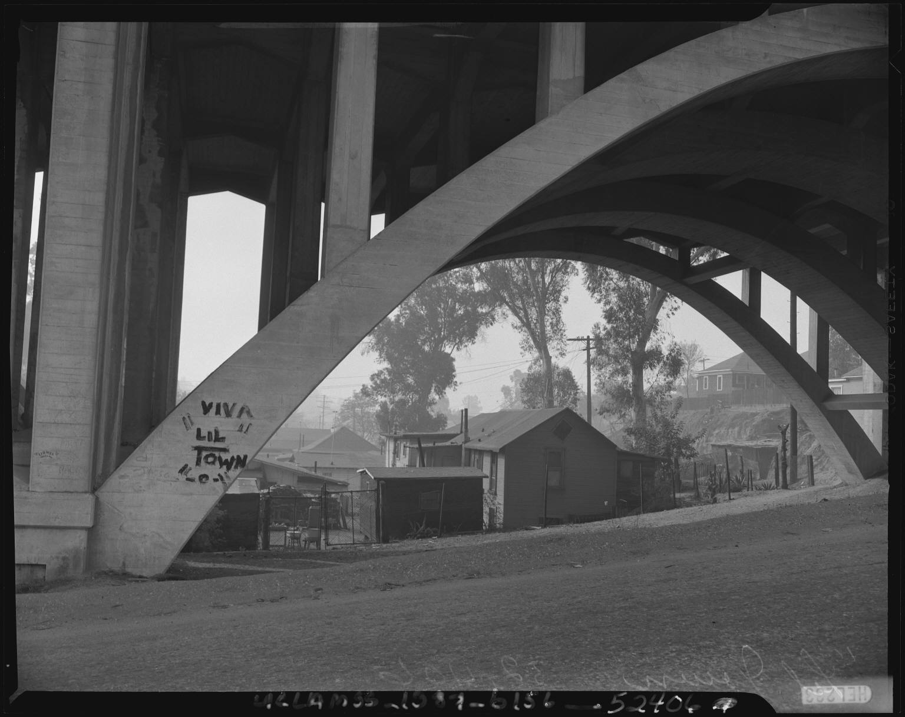
Image 1: View under bridge towards Chavez Ravine's "Lil' Town", Los Angeles (California), negative, 1950. Community Services Organization Series. Box 156, Negative 52406-1. Daily News Photos Archive (Collection 1387). Available online at http://content.cdlib.org/ark:/13030/hb4199n935/?brand=calcultures (accessed June 2006).

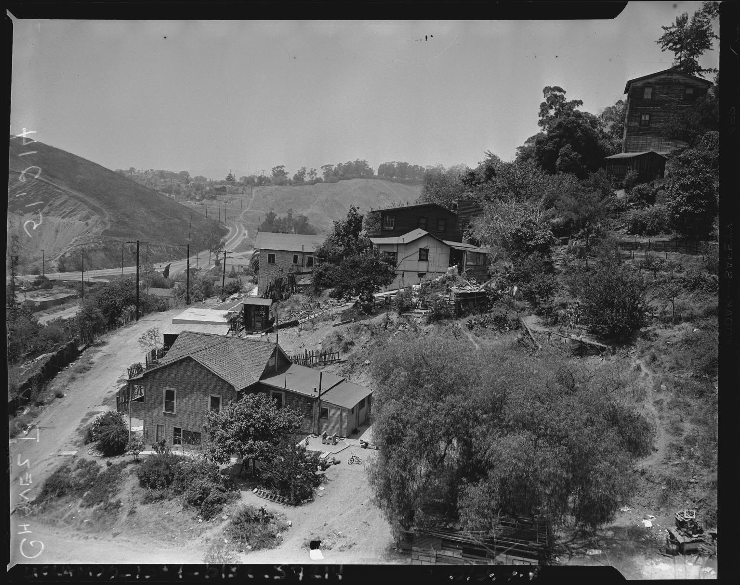 | 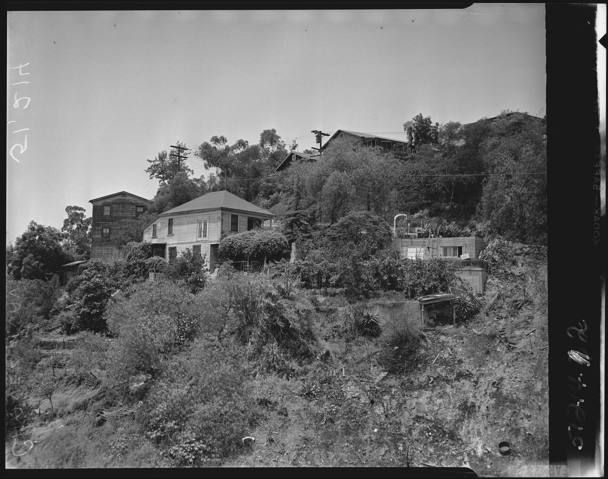 | 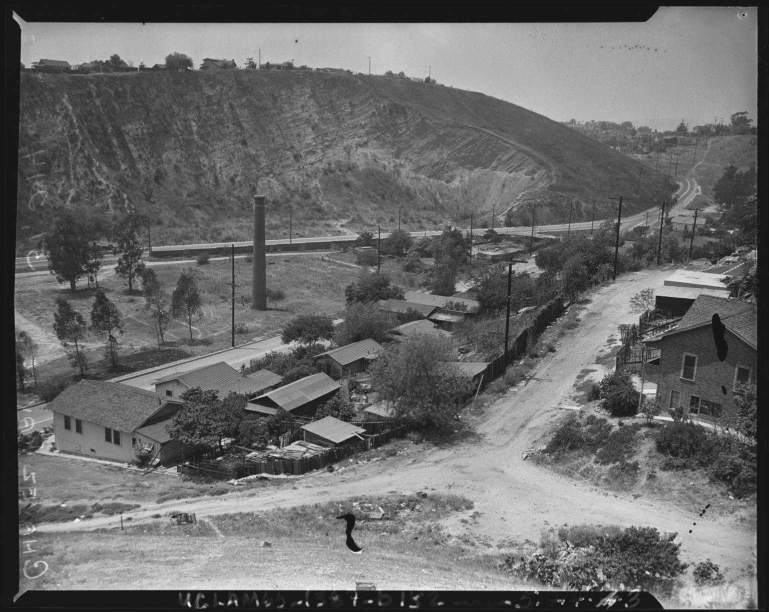
Image 2 | Image 3 | Image 4
Images 2-4: Hillside view of Chavez Ravine, Los Angeles (California), negatives, 1953. Box 152, Negative 51214. Daily News Photos Archive (Collection 1387). Available online at http://content.cdlib.org/ark:/13030/hb2779n7ws/?brand=calcultures, http://content.cdlib.org/ark:/13030/hb7489p0v7/?brand=calcultures, and http://content.cdlib.org/ark:/13030/hb587006ck/?brand=calcultures (accessed June 2006).
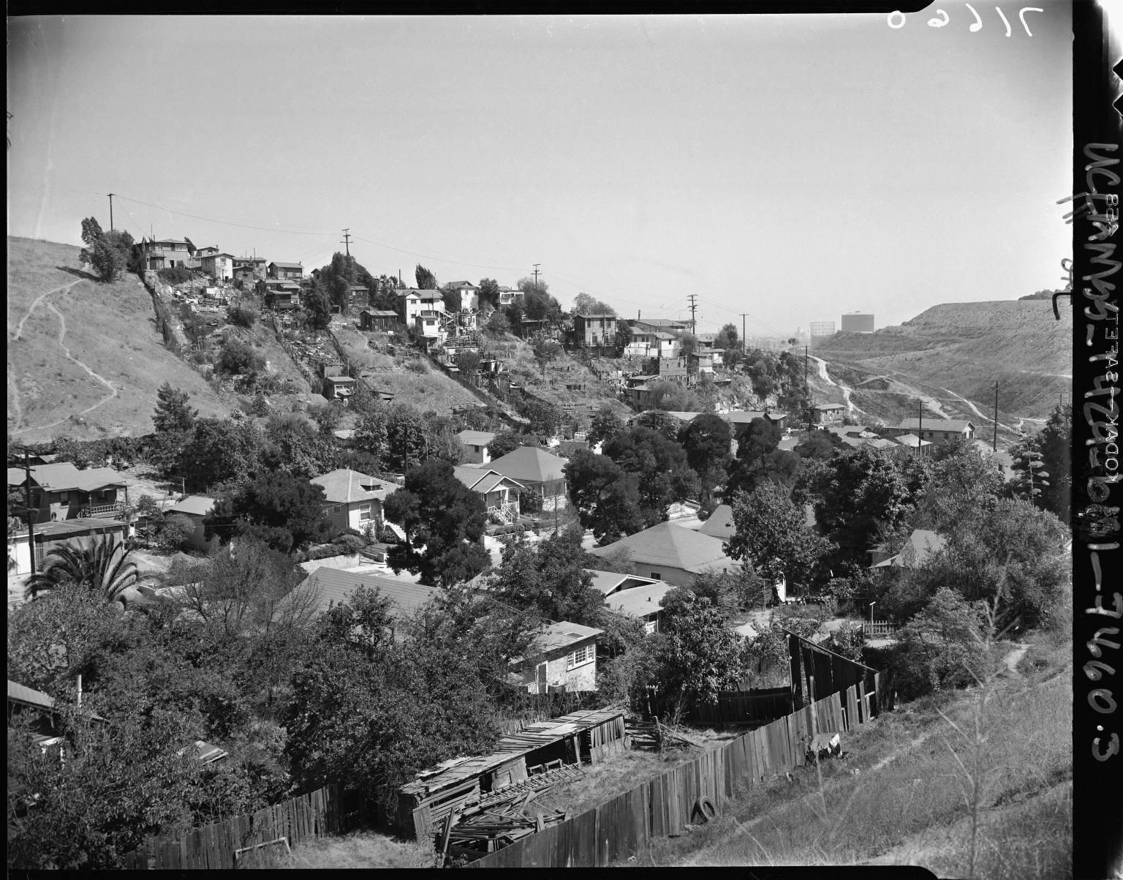
Image 5: Hillside view of Chavez Ravine, Los Angeles (California), negative, 1951. Box 131, Negative 71660-3. Los Angeles Times Photographic Archive (Collection 1429). Available online at http://content.cdlib.org/ark:/13030/hb2g5004c0/?brand=calcultures (accessed June 2006).

Set 2
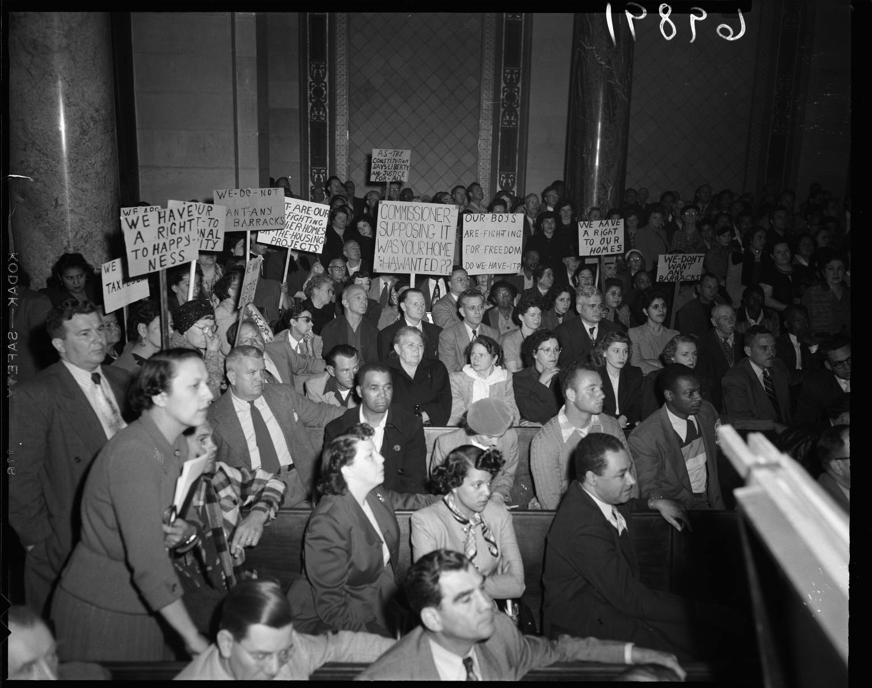
Image 6: Chavez Ravine property owners protest Elysian Park public housing development, Los Angeles (California), negative, 1951. Box 123, Negative 69891. Los Angeles Times Photographic Archive (Collection 1429). Available online at http://content.cdlib.org/ark:/13030/hb0s200347/?brand=calcultures (accessed June 2006).

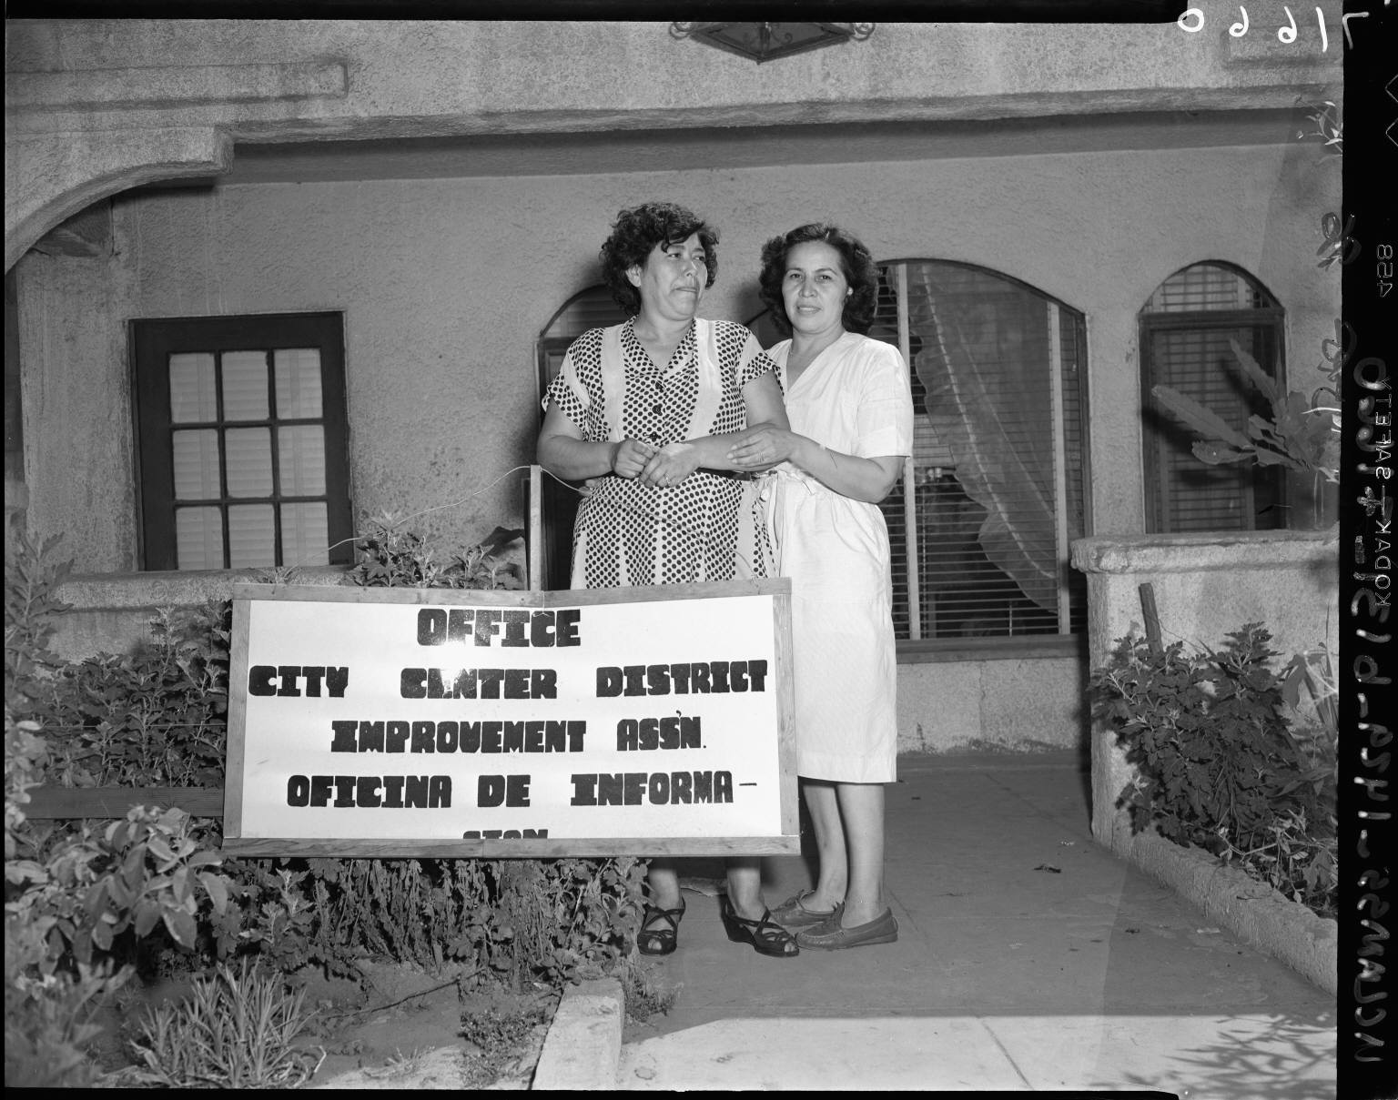
Image 7: Chavez Ravine residents refuse eviction order, Los Angeles (California), negative, 1951. Box 131, Negative 71660. Los Angeles Times Photographic Archive (Collection 1429). Available online at http://content.cdlib.org/ark:/13030/hb5r29p0w2/?brand=calcultures (accessed June 2006).

Doc 1: Here are the facts on City-Dodger contract, flier, 1958. Box 6, Folder CR1. Edward Ross Roybal Papers (Collection 847). Available online at http://content.cdlib.org/ark:/13030/hb467nb4gh/?brand=calcultures (accessed June 2006).

Doc 2: Citizens’ Committee to Save Chavez Ravine for the People: fact sheet, flier, 1957. Box 6, Folder CR1. Edward Ross Roybal Papers (Collection 847). Available online at http://content.cdlib.org/ark:/13030/hb1b69n999/?brand=calcultures (accessed June 2006).

Set 3

Doc 3: Letter, 1959 May, Texas, to City Council, Los Angeles, California Box 6, Folder CR3. Edward Ross Roybal Papers (Collection 847). Available online at http://content.cdlib.org/ark:/13030/hb5v19p1w/?brand=calcultures (accessed June 2006).

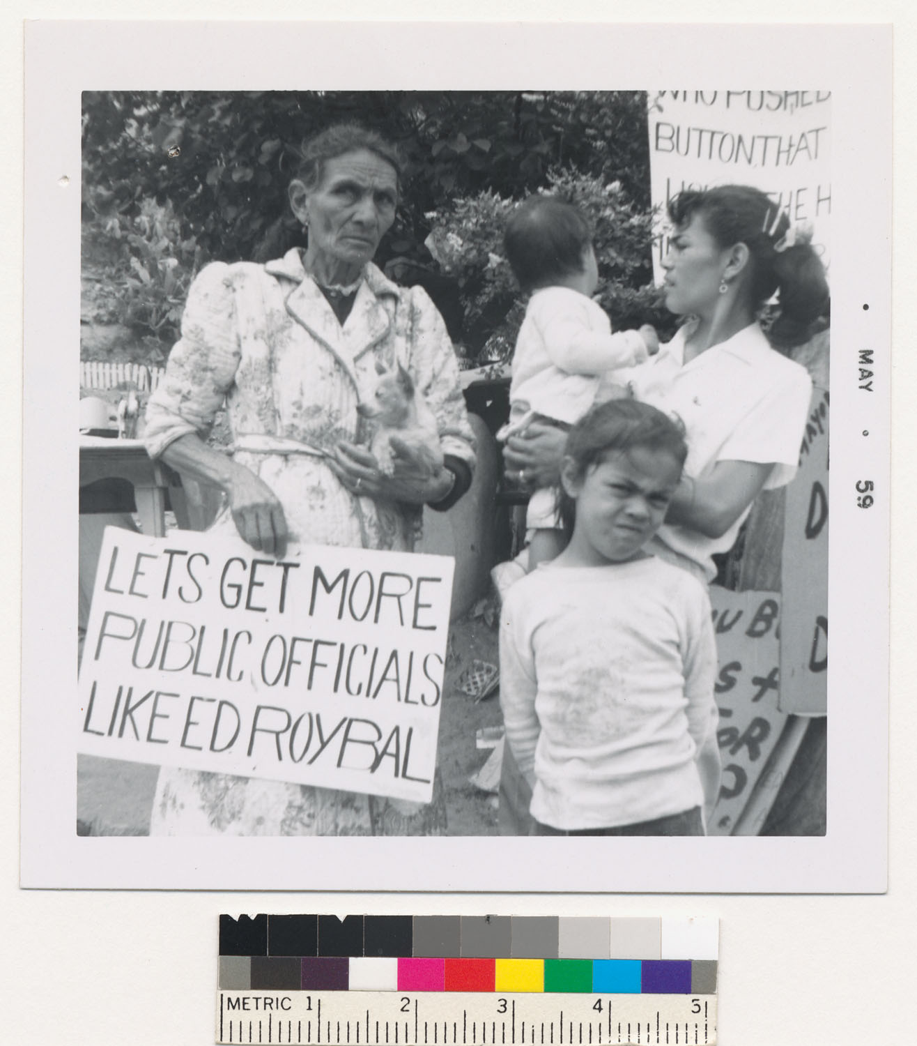
Image 8: Abrana Arechiga holds sign expressing support for Ed Roybal, photograph, 1959. Box 6, Folder CR3. Edward Ross Roybal Papers (Collection 847). Available online at http://content.cdlib.org/ark:/13030/hb4n39p2c9/?brand=calcultures (accessed June 2006).

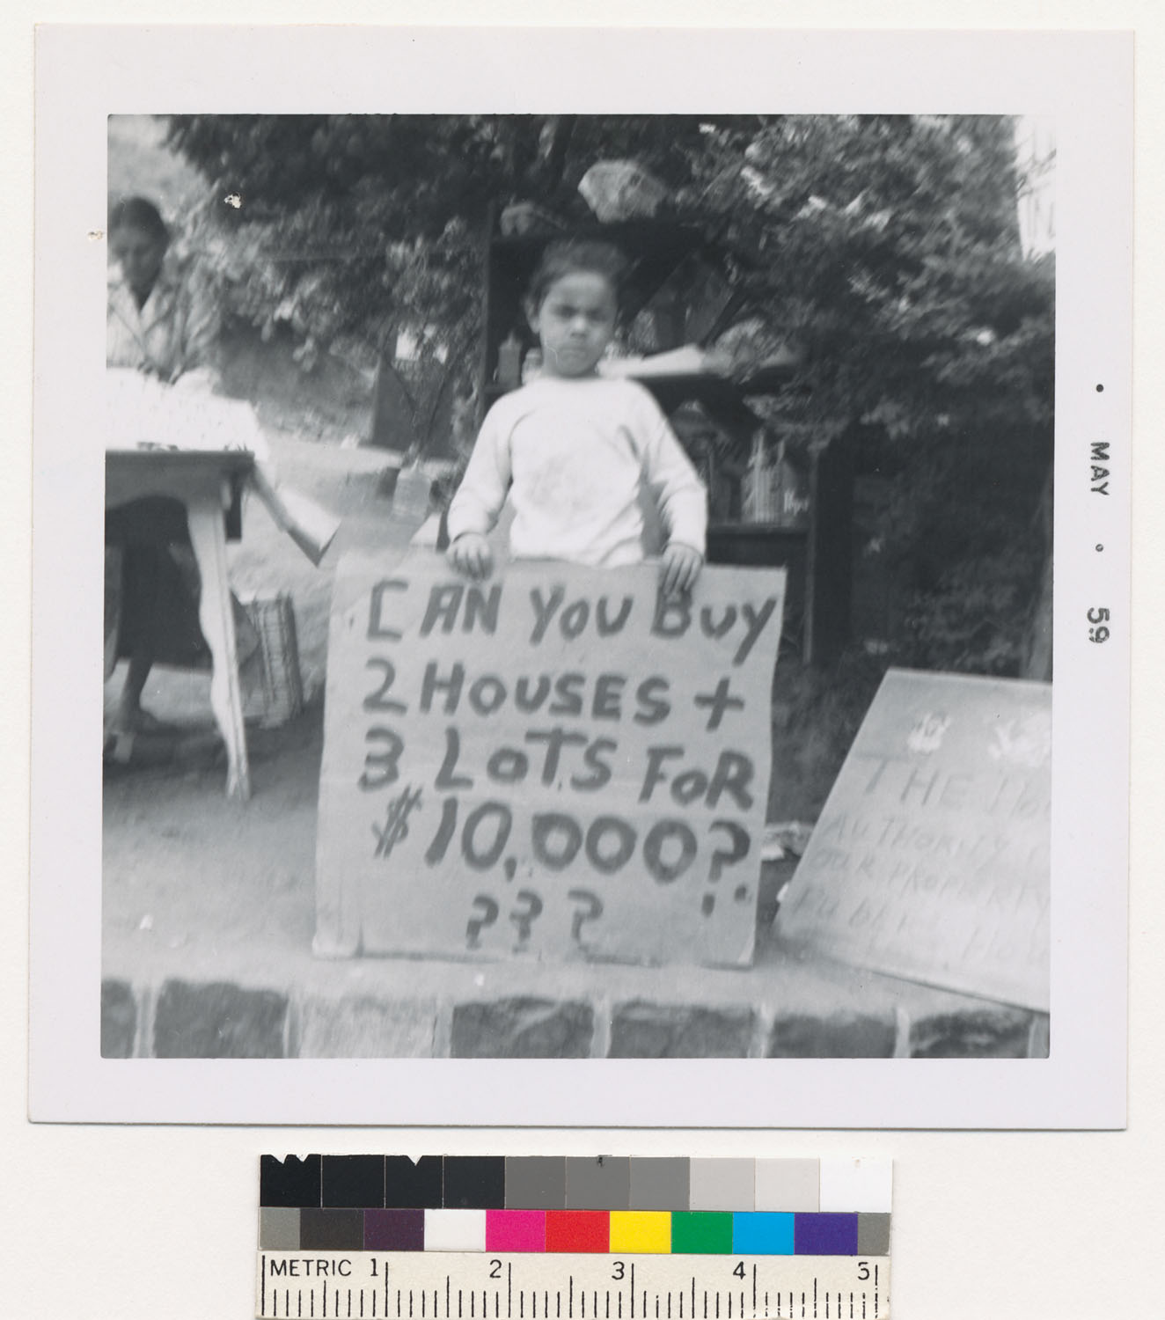
Image 9: Young girl at Chavez Ravine holding a sign, photograph, 1959. Box 6, Folder CR3. Edward Ross Roybal Papers (Collection 847). Available online at http://content.cdlib.org/ark:/13030/hb6779p4vh/?brand=calcultures (accessed June 2006).

Doc 4: Letter, 1959 May 9, Whittier, California To Mr. Roybal, Councilman, Los Angeles, California Box 6, Folder CR3. Edward Ross Roybal Papers (Collection 847). Available online at http://content.cdlib.org/ark:/13030/hb8t1nb7g4/?brand=calcultures (accessed June 2006).

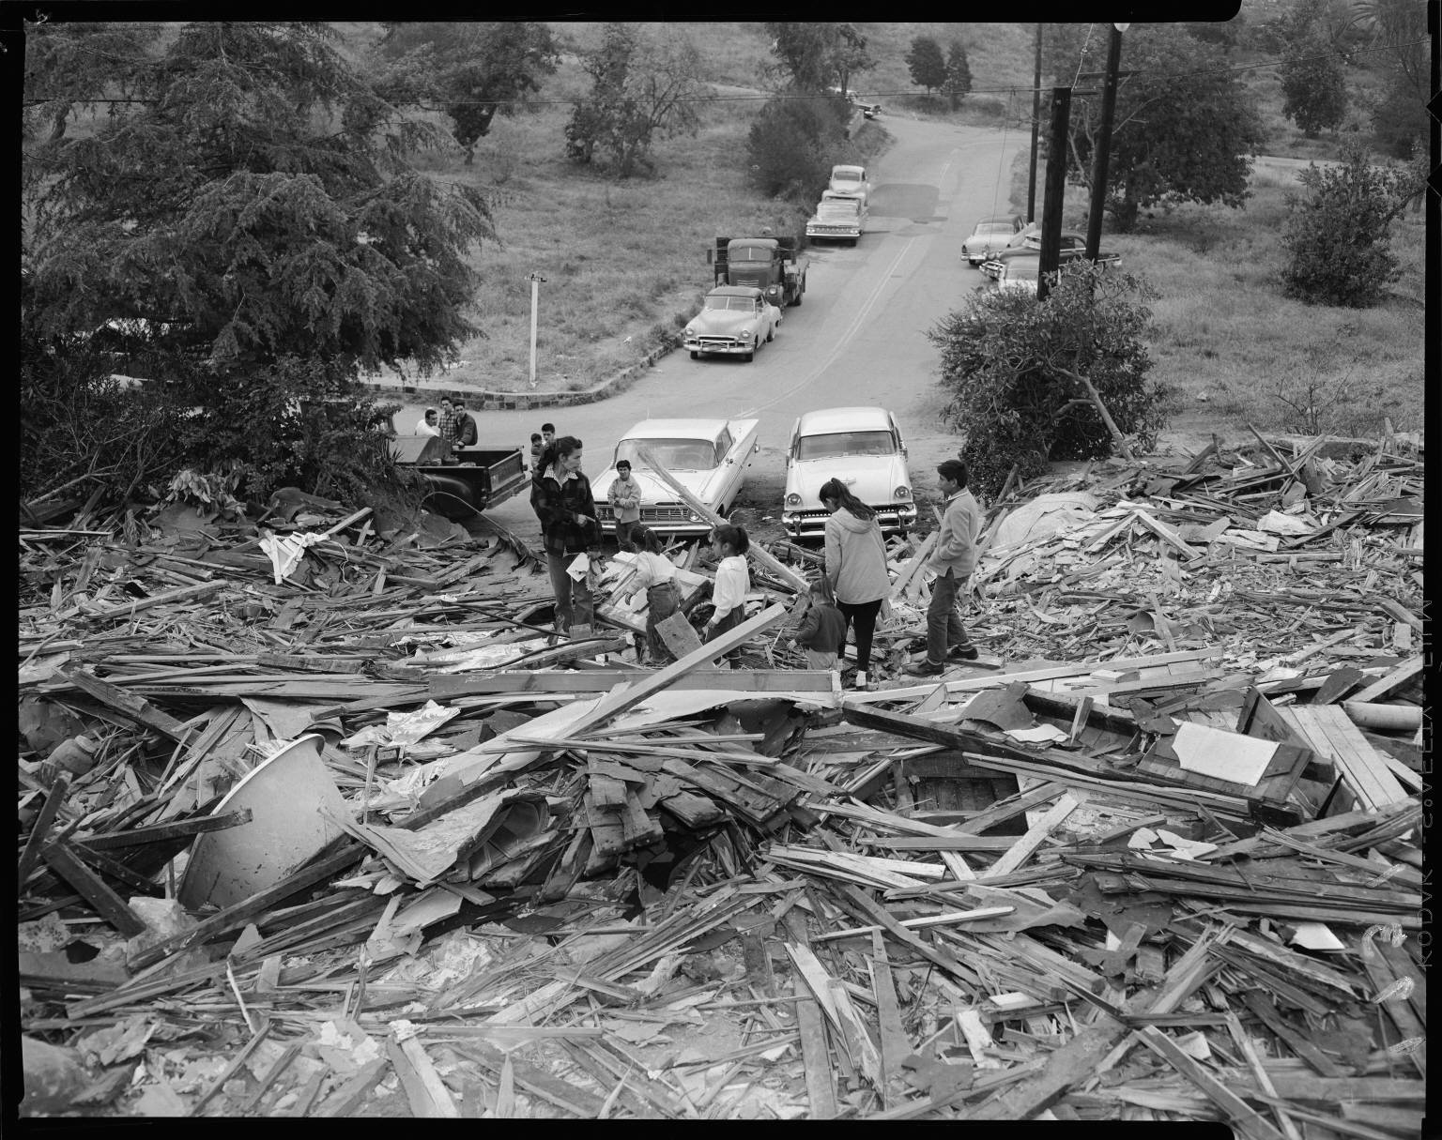
Image 10: Chavez Ravine property owners examine bulldozed ruins, Los Angeles (California), negative, 1959. Box 382, Negative 116242-F. Los Angeles Times Photographic Archive (Collection 1429). Available online at http://content.cdlib.org/ark:/13030/hb800008s8/?brand=calcultures (accessed June 2006).

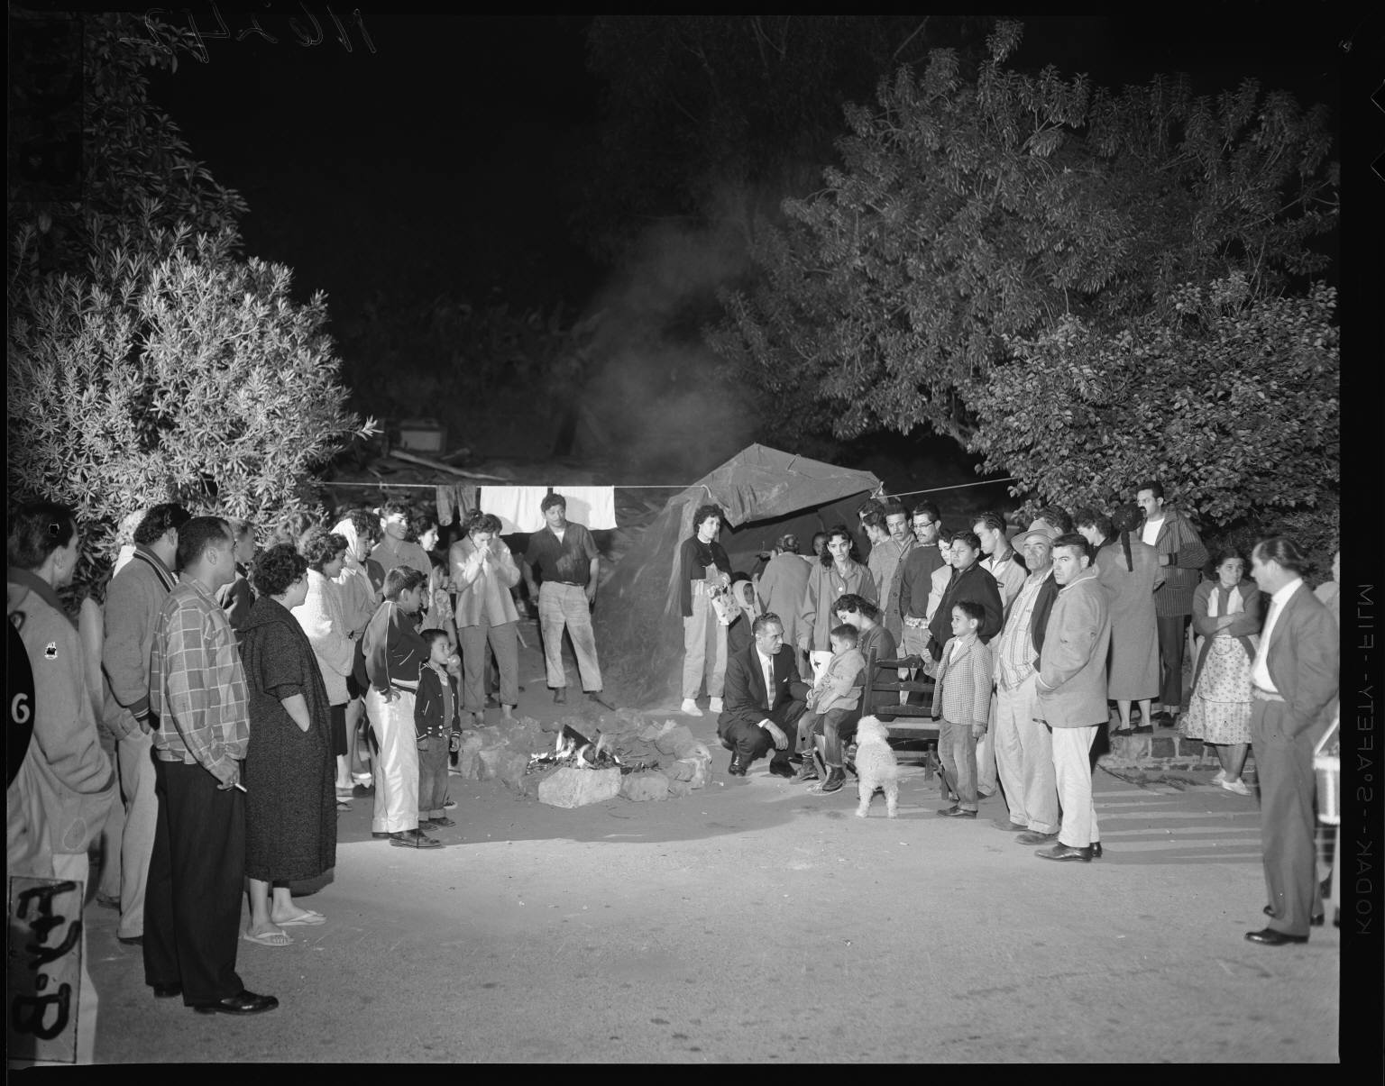
Image 11: Chavez Ravine residents confer with Councilman Roybal after eviction, Los Angeles (California), negative, 1959. Box 382, Negative 116242-C. Los Angeles Times Photographic Archive (Collection 1429). Available online at http://content.cdlib.org/ark:/13030/hb8s2008x1/?brand=calcultures (accessed June 2006).

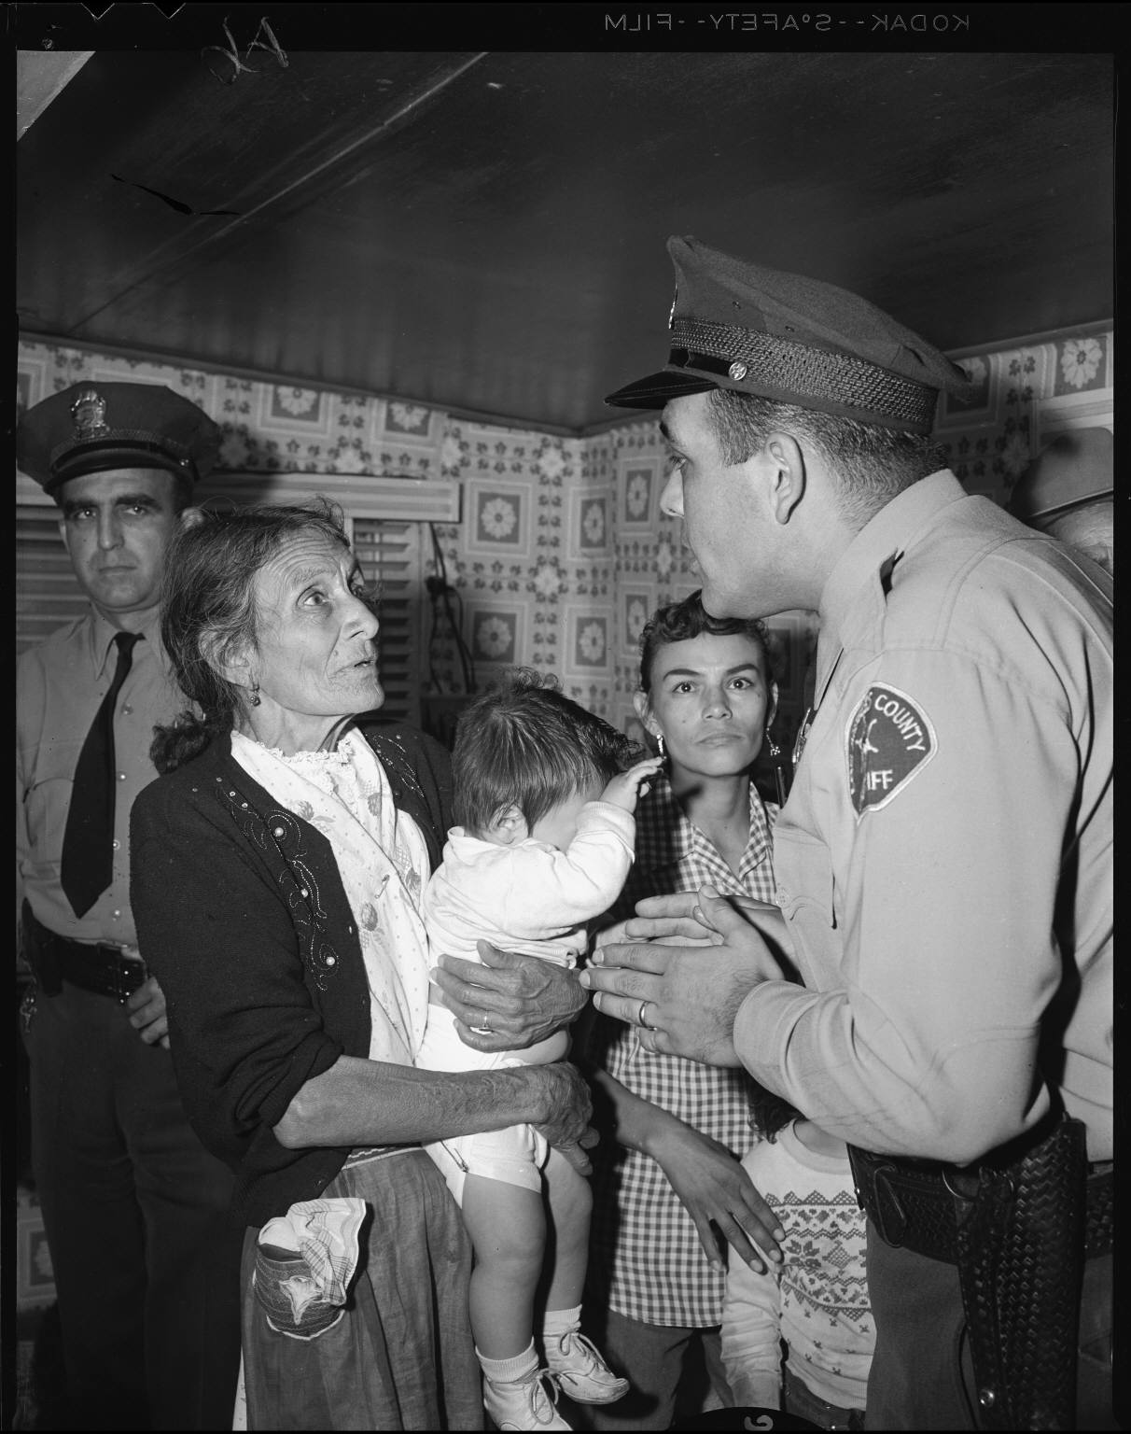
Image 12: Sheriff deputies evict Abrana Arechiga from Chavez Ravine home, Los Angeles (California), negative, 1959. Box 382, Negative 116242-G. Los Angeles Times Photographic Archive (Collection 1429). Available online at http://content.cdlib.org/ark:/13030/hb038nb0c4/?brand=calcultures (accessed June 2006).

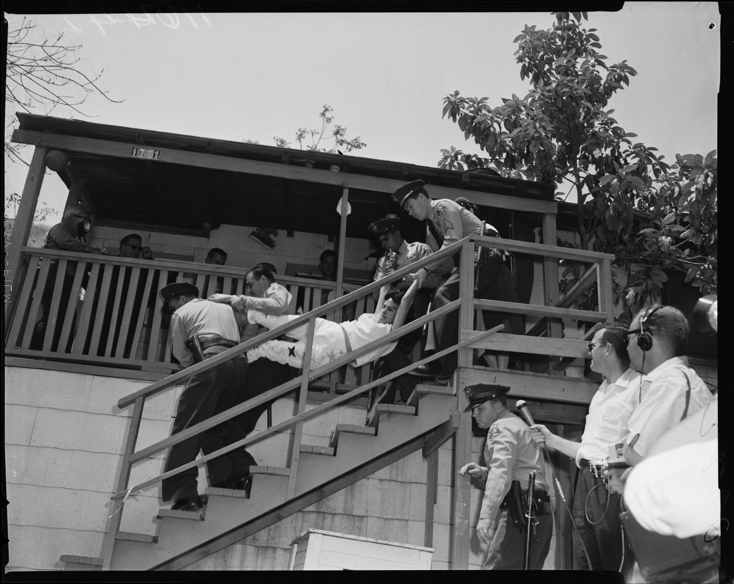
Image 13: Angustain family evicted from home in Chavez Ravine, Los Angeles (California), negative, 1959. Box 382, Negative 116242. Los Angeles Times Photographic Archive (Collection 1429). Available online at http://content-dev.cdlib.org/ark:/13030/kt467nc6wg/?brand=calcultures (accessed June 2006).

Doc 5: Letter, 1959 May 13, South Gate, California To Councilman Roybal, Los Angeles, California Box 6, Folder CR3. Edward Ross Roybal Papers (Collection 847). Available online at http://content.cdlib.org/ark:/13030/hb7m3nb6r5/?brand=calcultures (accessed June 2006).

Doc 6: Postcards, 1959 May, to Councilman Edward R. Roybal, City Hall, Los Angeles, California Box 6, Folder CR3. Edward Ross Roybal Papers (Collection 847). Available online at http://content.cdlib.org/ark:/13030/kt1s20193q/?brand=calcultures (accessed June 2006).
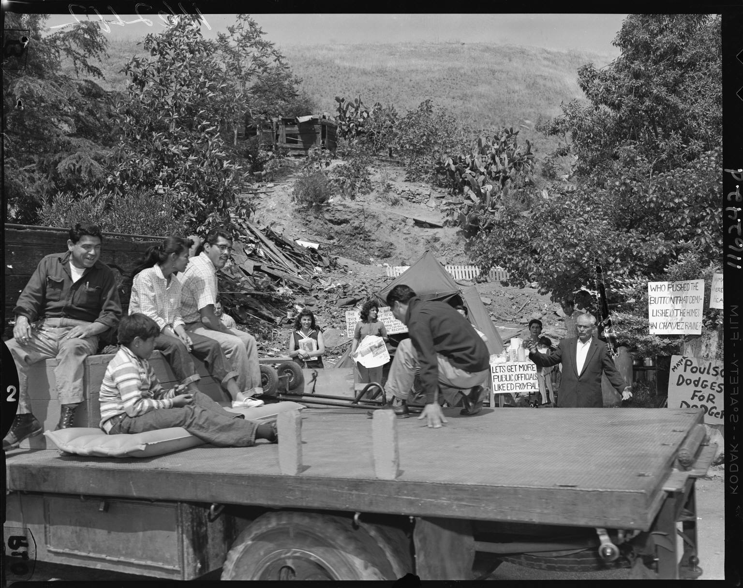
Image 14: Chavez Ravine residents wave good-bye from truck, Los Angeles (California), negative, 1959. Box 382, Negative 116242-D. Los Angeles Times Photographic Archive (Collection 1429).
http://content.cdlib.org/ark:/13030/hb4779n9fn/?brand=calcultures

Doc 7: Letter, 1959 May 25, City Hall, Los Angeles to Mrs. Lee A. Bell, Sylmar, California Box 6, Folder CR3. Edward Ross Roybal Papers (Collection 847). Available online at http://content.cdlib.org/ark:/13030/hb4g5007k5/?brand=calcultures (accessed June 2006).

BIBLIOGRAPHY

Secondary Sources

Binford, Henry C. “Slums.” In Paul Boyer, ed. Oxford Companion to United States History. New York: Oxford University Press. 2001.

California Biographical Dictionary, 4th ed. Volume 2. St. Clair Shores, MI: Somerset Publishers, 1998.

Gugliotta, Guy. Dole Urges Abolition of Public Housing: Voucher Proposal Echoes Ill-Fated HUD Plan. Washington Post. Section A, p. A5. 30 April 1996.

Hartman, Chester. Between Eminence and Notoriety: Four Decades of Radical Urban Planning. New Brunswick, NJ: Center for Urban Policy Research, Rutgers, State University of New Jersey. 2002.

Hines, Thomas S. Field of Dreams: The Battle of Chavez Ravine. Los Angeles Times. Section M, p. 1. 20 April 1997.

Klein, Norman M. The History of Forgetting: Los Angeles and the Erasure of Memory. New York: Verso. 1997.

Lang, Robert E. and Rebecca R. Sohmer. Editor’s Introduction: Legacy of the Housing Act of 1949: The Past, Present and Future of Federal Housing and Urban Policy. Housing Policy Debate, 11(2). Available: http://Www.Fanniemaefoundation.Org/Programs/Hpd/Pdf/Hpd_1102_Edintro.Pdf Accessed on August 10, 2003.

Martinez, Sylvia C. The Housing Act of 1949: Its Place in the Realization of the American Dream of Homeownership. Housing Policy Debate, 11(2). Available: http://www.fanniemaefoundation.org/programs/hpd/pdf/hpd_1102_martinez.pdf Accessed August 10, 2003.

Normark, Don. Chavez Ravine, 1949: A Los Angeles Story. San Francisco: Chronicle Books, 1999.

Potter, Lee Ann. Teaching with documents: Letter from President Lyndon B. Johnson to John Steinbeck. Social Education, 67. 196−199. 2003.

Rampersad, Arnold. Jackie Robinson: A Biography. New York: Alfred A. Knopf, 1997.

Tawa, Renee. “Family Album/A Profile of a Community—Its History, Joys, Trials. Field of Uprooted Dreams.” Los Angeles Times. Section E, p. 1. 11 July 1999.

Related Web Sites

American Memory. By Popular Demand: Jackie Robinson and other Baseball Highlights, 1860s to 1960s. http://memory.loc.gov/ammem/collections/robinson/ Library of Congress. 19 October 1998. Accessed 27 August 2003.

Berner, Martha. Views and Voices from Within: The Art and Writing of Estelle Ishigo, Heart Mountain Internment Camp, 1942−1945. http://ipr.ues.gseis.ucla.edu/classroom/IshigoPlans/mblessson/mblesson.html 2001. Institute on Primary Resources, University of California, Los Angeles.

Dodgers, MLB.com. Dodger Stadium. http://losangeles.dodgers.mlb.com/NASApp/mlb/la/ballpark/la_ballpark_history.jsp 2003.

Venn Diagram Basic. The Graphic Organizer. http://www.graphic.org/venbas.html

Hill, G. and Hill, K. The Real Life Dictionary of the Law. http://dictionary.law.com/

National Archives and Records Administration. “Teaching with Documents Lesson Plan: Beyond the Playing Field — Jackie Robinson, Civil Rights Advocate.” Teaching with Documents. http://www.archives.gov/education/lessons/jackie-robinson/
Accessed 27 August 2003.

PBS. Zoot Suit Riots: Los Angeles Erupts in Violence. 1999−2002. American Experience | Zoot Suit Riots. http://www.pbs.org/wgbh/amex/zoot/

Roybal, Edward Ross 1916−. Biographical Dictionary of the United States Congress, 1774−Present. http://bioguide.congress.gov/scripts/biodisplay.pl?index=R000485

APPENDIX: CHAVEZ RAVINE CHRONOLOGY

1949: National Housing Act of 1949 (Taft-Wagner-Ellender Bill)
July 24, 1950: Los Angeles Housing Authority begins buying property in Chavez Ravine for a public housing project.
August 31, 1951: President Truman signs a bill sponsored by Senator Harry P. Cain that federal money cannot be used for a housing project if the local governing body (e.g., city council) objects.
December 1951: Los Angeles City Council, under pressure because public housing is considered too socialistic, cancels the public housing contract. One prominent group (led by Frederick Dockweiler) opposed to public housing was known as Citizens Against Socialist Housing (CASH).
April 28, 1952: California Supreme Court orders Los Angeles to honor the housing contract, but the Los Angeles City Council sends the issue to a popular vote instead. Fully 59% of city residents are against continuing the public housing project.
June 11, 1953: Norris Poulson becomes mayor of Los Angeles, succeeding Fletcher Bowron.
August 1953: Los Angeles City Housing Authority, having purchased much of the land in Chavez Ravine, sells the area to the city of Los Angeles. Congress agrees to pay over 4 million dollars and the city agrees to pay $1.25 million to complete this transaction. The city agrees to use the property for a “public purpose.”
October 7, 1957: Los Angeles City Council approves a resolution to transfer Chavez Ravine to a private business, the Brooklyn Dodgers.
1958: Referendum to block transfer of public land to a private business put to a vote. Dodgers win with a margin of less than 2%.
May 9, 1959: Sheriff’s deputies forcibly evict the remaining residents of Chavez Ravine.
September 27, 1959: Ground broken for Dodger Stadium.

April 1962: Dodger Stadium http://losangeles.dodgers.mlb.com/NASApp/mlb/la/ballpark/la_ballpark_history.jsp opens.

Last revised: July 11, 2006.

